Project Report Format

# INTRODUCTION

* 1. Project Overview
  2. Purpose

# IDEATION PHASE

* 1. Problem Statement
  2. Empathy Map Canvas
  3. Brainstorming

# REQUIREMENT ANALYSIS

* 1. Customer Journey map
  2. Solution Requirement
  3. Data Flow Diagram
  4. Technology Stack

# PROJECT DESIGN

* 1. Problem Solution Fit
  2. Proposed Solution
  3. Solution Architecture

# PROJECT PLANNING & SCHEDULING

* 1. Project Planning

# FUNCTIONAL AND PERFORMANCE TESTING

* 1. Performance Testing

# RESULTS

* 1. Output Screenshots

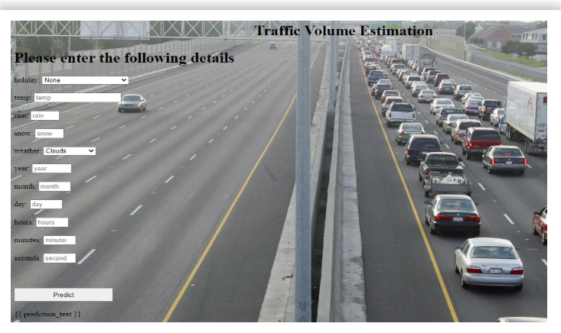 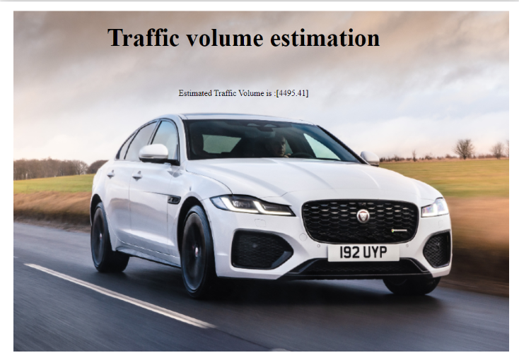

1. **ADVANTAGES & DISADVANTAGES**

Advantages :

1. Accurate Traffic Volume Predictions
2. Optimized Traffic Flow
3. Data-Driven Decision Making
4. Reduced Environmental Impact
5. Scalable & Adaptable

Disadvantages :

1. Data Dependency
2. Hardware Limitations
3. Real-time Processing Latency
4. Dependency on Network Connectivity
5. Complex Model Maintenance
6. **CONCLUSION**

The Traffic Intelligence project presents a modern , data-driven solution to address growing urban traffic challenges. It helps reduce congestion , improve traffic flow and support smart city planning. The system is scalable and environmentally beneficial , making transportation more sustainable.

1. **FUTURE SCOPE**

In future , the Traffic Intelligence system can be integrated with autonomous vehicles and smart traffic lights. Predictive analytics can be enhanced using multi-source data like weather and social media.

1. **APPENDIX**

Dataset Link : https://drive.google.com/file/d/1iV5PfYAmI6YP0_0S4KYy1ZahHOqMgDbM/view

GitHub Link : <https://github.com/Eswar02104/Traffic_Intelligence>

Demo Link : <https://drive.google.com/file/d/1ZDGx9sX7SqXfADRW9mwTQg-FA33iN9JO/view?usp=drive_link>